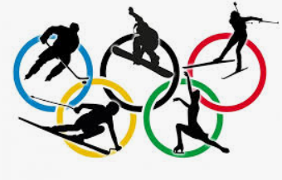
School Olympics
Summer edition | Original | Online edition | Winter edition | Christmas edition
In summer edition school rents town's pool for the games. The activities are fun but hard like snorkelling, swimming and for the creative pupils there are sketching and designing swimsuits that are made from the old ones. | In original there are original, basic games like football, basketball and badmington. Creative pupils are designing a flag that represents their class. | In online edition students have a fun knowledge quiz about Internet comunication. Pupils design pandemic masks and hard tasks like spotting something on the picture etc. (Only in cases of pandemics like nowadays). | In winter pupils do fun activities in snow or on ice like skiing, ice skating, ice hockey and designing a jacket from the old one. | Christmas edition is held on December 22nd inside the school fra Pavla Vučkovića. Pupils are designing decorations for Christmas tree and supplies are bought by school. Then pupils compete in who will decorate the tree first. Finally, there is an amazing competition of who is going to wrap a present first. Presents contain a gift for the kids that were competing and the teachers from the school.

In Sinj, December 2020 Made by: Duje Klarić Kukuz 6.B.

